Objective Questions Chapter 7

- The languages PALINDROME and PRIME are the examples of ….
a. nonregular languages c. formal languages
b. regular languages d. nonformal languages

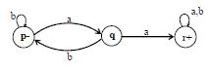
- Let r₁ = (a+b)*aa(a+b)* and FA₁ be

a. (a+b)*aa(a+b)* c. (aa+bb)*aa(a+b)*
b. (a+b)*bb(a+b)* d. (a+b)*a(a+b)*

- The meaning of Nonregular languages is ?
a. The language that cannot be expressed by any regular expression
b. The language that be expressed by any regular expression
c. The language that cannot be expressed by any nonregular expression
d. all answers are wrong

- Let P=a*, Q be the product of {a^{n}b^{n}:n=0,1,2,…} and b* then ………
a. PQ=a*{a^{n}b^{n}}b*=a*b*=R c. PQ=b*{a^{n}b^{n}}b*=a*b*=R
b. PQ=a*{a^{n}b^{n}}a*=a*b*=R d. PQ=a*{b^{n}a^{n}}b*=a*b*=R

- Let Q = {aa,abaaabb,bbaaaaa,bbbbbbbbbb} and R = {b,bbbb,bbbaaa,bbbaaaaa}
The prefixes is ?
a. pref(Q in R) = {b,bbba,bbbaaa} c. pref(Q in R) = {b,aaab,bbbaaa}
b. pref(Q in R) = {a,bbba,bbbaaa} d. pref(Q in R) = {b,bbba,aaabbb}
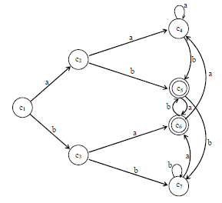

C₇ is ?
a. set of strings ending in bb c. set of strings ending in aa
b. set containing only letter b d. set containing only null string

- the language PRIME, of strings defined over ∑ = {a}, as {ap : p is prime} is..?
a. PRIME = {aa, aaa, aaaaa, aaaaaaa, …} c. PRIME = {aa, aaa, aaaaa, aaabbb, …}
b. PRIME = {aaa, aaaa,a aaaaa, aaaaaaa, …} d. PRIME = {ab, aab, aaabb, aaaabbb, …}

- For three languages P,Q and R, while PQ=R the language Q must be regular if both P and R are regular.
This is statement of ??
a. Pseudo theorem c. Myhill Nerode theorem
b. Prefix of languages d. Pumping lemma version

- r₁ = (a+b)*aa(a+b)*
r₂ = (b+ab*a)*
Now FAs accepting L₁^{c} and L₂^{c} , by definition, may be…
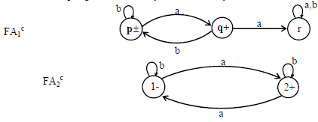
a.

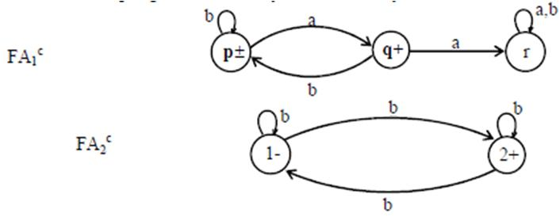
b.

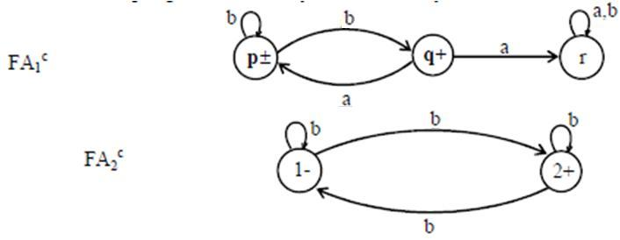
c.

d. All answer is wrong

